IMPLEMENTATION OF LIST LINEAR AND BINARY SEARCH USING ADT

AIM :
Implementation of list linear and binary using ADT for a given element in the list.

PSEUDO CODE :

START
Create an empty List
Insert 10, 20, 30, 40, 50 into the List
Display the List
Read the search key

// Linear Search
FOR each element in the List
IF element = key
Display "Element Found"
STOP
END FOR
Display "Element Not Found"
// Binary Search
Set low = 0
Set high = size - 1

WHILE low <= high
mid = (low + high) / 2

IF list[mid] = key
Display "Element Found"
STOP

ELSE IF key > list[mid]
low = mid + 1

ELSE
high = mid - 1
END WHILE

Display "Element Not Found"

STOP

Code :
#include <stdio.h>

#define MAX 100

// List ADT structure
typedef struct
{
int arr[MAX];
int size;
} List;

// Function to initialize the list
void initList(List *L)
{
L->size = 0;
}

// Function to insert an element
void insert(List *L, int value)
{
if (L->size < MAX)
{
L->arr[L->size] = value;
L->size++;
}
else
{
printf("List is full\n");
}
}

// Function to display the list
void display(List L)
{
int i;
printf("List elements: ");
for (i = 0; i < L.size; i++)
{
printf("%d ", L.arr[i]);
}
printf("\n");
}

// Linear Search
int linearSearch(List L, int key)
{
int i;

for (i = 0; i < L.size; i++)
{
if (L.arr[i] == key)
{
return i;
}
}

return -1;
}

// Binary Search (List must be sorted)
int binarySearch(List L, int key)
{
int low = 0;
int high = L.size - 1;
int mid;

while (low <= high)
{
mid = (low + high) / 2;

if (L.arr[mid] == key)
{
return mid;
}
else if (L.arr[mid] < key)
{
low = mid + 1;
}
else
{
high = mid - 1;
}
}

return -1;
}

// Main Function
int main()
{
List L;
int key, pos;

initList(&L);

// Insert sorted elements
insert(&L, 10);
insert(&L, 20);
insert(&L, 30);
insert(&L, 40);
insert(&L, 50);

display(L);

printf("Enter element to search: ");
scanf("%d", &key);

// Linear Search
pos = linearSearch(L, key);

if (pos != -1)
printf("Linear Search: Element found at index %d\n", pos);
else
printf("Linear Search: Element not found\n");

// Binary Search
pos = binarySearch(L, key);

if (pos != -1)
printf("Binary Search: Element found at index %d\n", pos);
else
printf("Binary Search: Element not found\n");

return 0;
}

Output :

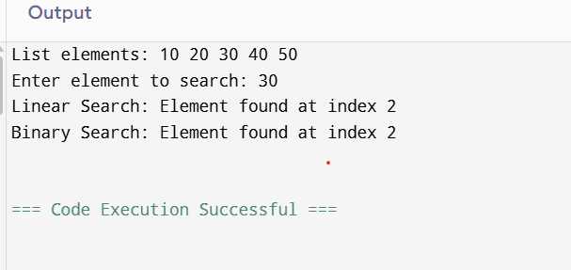

RESULT :
The List ADT was successfully implemented using C, and both Linear Search and Binary Search operations were performed successfully. The program correctly searched for the given element and displayed whether it was found or not.

